THE UNIVERSITY OF AUCKLAND

SECOND SEMESTER, 2007
Campus: City

STATISTICS

Statistical Methods in Marketing

(Time allowed: TWO hours)

NOTE: Complete ALL SIX questions. Each question has its total marks next to its number and part marks for each part thereof. Two pages of formulae for various probability models are attached for your reference (pages 10 and 11).

1. [7 marks]

Your client has commissioned a nationwide telephone survey of 1000 beer drinkers to investigate their consumption of and attitudes towards various beer brands. A stratified sample of households was selected, with one beer drinker aged 15 or more being selected at random from those in each household (if any were present). Beer drinkers were defined as those people who drank beer during the last month. The resulting dataset includes the following variables:

Variable name | Variable label
Stratum | ID number of current sample stratum
Date | Date of interview
Area | Area number
Hhldsize | Number of people living in this household
Hhld15plus | Number of people aged 15 or more living in this household
Hhldsizeb | Number of beer drinkers living in this household
Hhld15plusb | Number of beer drinkers aged 15 or more living in this household
Heineken | Drank Heineken during the last month

(a) Identify the elements of the survey design that should be taken into account when estimating the proportion of beer drinkers who drank Heineken during the last month, and when calculating an accurate confidence interval for this proportion. [4 marks]

(b) Briefly describe the effect you would expect each of these elements to have on the width of the confidence interval, when each factor is viewed in isolation. That is, would these factors tend to increase or decrease the size of the interval? [3 marks]

2. [40 marks]

A financial company wishes to know what are the most important drivers for increasing customers’ overall satisfaction with their company. With this in mind each customer was asked (from a total of 401 customers):

And on a scale from 1 to 5 where 1 means not at all satisfied with (this financial company) and 5 means extremely satisfied, how satisfied are you with (this financial company)? WRITE IN

They were also asked to answer the following questions:

I am going to read out a number of statements that might be used to describe a financial services company. As I read each one, could you please indicate how strongly you agree or disagree that each of the statements describes (this financial company) using a scale from 1 to 5 where 1 means you strongly disagree, and 5 means you strongly agree. There are no right or wrong answers; it is your opinion that is important …
STATEMENTS SHOULD BE RANDOMISED/ROTATED

 | Strongly  Disagree | Disagree | Neither agree, nor disagree | Agree | Strongly  Agree | Do not know
Leaders in technology | 1 | 2 | 3 | 4 | 5 | 6
Think outside the square | 1 | 2 | 3 | 4 | 5 | 6
High performer in financial markets | 1 | 2 | 3 | 4 | 5 | 6
Company for people who want to achieve | 1 | 2 | 3 | 4 | 5 | 6
Experts in financial matters | 1 | 2 | 3 | 4 | 5 | 6
Dynamic and progressive | 1 | 2 | 3 | 4 | 5 | 6
Proactive with advice and suggestions | 1 | 2 | 3 | 4 | 5 | 6
Company you can trust | 1 | 2 | 3 | 4 | 5 | 6
Help customers achieve financial goals | 1 | 2 | 3 | 4 | 5 | 6
Honest and upfront | 1 | 2 | 3 | 4 | 5 | 6
Staff take responsibility | 1 | 2 | 3 | 4 | 5 | 6
Easy to deal with | 1 | 2 | 3 | 4 | 5 | 6
Treat customers with respect and recognition | 1 | 2 | 3 | 4 | 5 | 6
A company you can trust | 1 | 2 | 3 | 4 | 5 | 6

Question 2 continued

(a) The descriptions of the analyses of the above customer satisfaction survey do not discuss the extent or treatment of missing data, for example from “Don’t Know” responses. Now suppose that there was substantial missing data, accounting for 5-20% of respondents on each statement.

(i) Suppose that cases with missing data are simply deleted (list-wise deletion of missing data), and a linear regression analysis is conducted. Briefly describe the possible effects of this approach on the regression coefficients and their standard errors. [4 marks]

(ii) Now assume that the missing data is missing at random, i.e. it is not missing completely at random, but the probability that it is missing depends on other observed variables. Suggest an imputation method that is likely to give better results in this setting than mean imputation, and explain why. Briefly describe how this method works in your answer.
[4 marks]

The following output showing performances (mean values) and importances (in this case, correlations) was obtained (after the data was ‘cleaned’)):

Question 2 continued

 | Performance | Importance
Leaders in technology | 3.47 | 0.52
Wide range of products | 4.10 | 0.46
Think outside the square | 3.35 | 0.41
High performer in financial markets | 3.69 | 0.30
Company for people who want to achieve | 3.69 | 0.47
Experts in financial matters | 3.88 | 0.41
Dynamic and progressive | 3.59 | 0.52
Proactive with advice and suggestions | 3.50 | 0.57
Company you can trust | 4.13 | 0.53
Help customers achieve financial goals | 3.68 | 0.43
Honest and upfront | 4.02 | 0.49
Staff take responsibility | 3.68 | 0.55
Easy to deal with | 3.96 | 0.52
Treat customers with respect and recognition | 3.99 | 0.34

- After inspecting the data and plots, above, briefly describe your recommendations to this financial company. [8 marks]

(c) The data analyst performed a multiple linear regression with ‘overall satisfaction’ as the response. The following S-plus output was obtained:

Coefficients:
Value Std. Error t value Pr(>|t|)
(Intercept) 0.5969 0.2307 2.5875 0.0100
Leaders.in.technology -0.0633 0.0585 -1.0815 0.2802
Wide.range.of.products 0.0020 0.0538 0.0368 0.9706
Think.outside.the.square -0.0384 0.0536 -0.7161 0.4744
High.performer.in.financial.mark 0.0526 0.0558 0.9427 0.3464
Company.for.people.who.want.to.a -0.0085 0.0586 -0.1451 0.8847
Experts.in.financial.matters 0.0505 0.0582 0.8682 0.3858
Dynamic.and.progressive 0.1569 0.0543 2.8874 0.0041
Proactive.with.advice.and.sugges 0.0258 0.0457 0.5657 0.5719
Company.you.can.trust 0.1074 0.0606 1.7724 0.0771
Help.customers.ahcieve.financial 0.0670 0.0532 1.2580 0.2091
Honest.and.upfrount 0.0706 0.0605 1.1674 0.2438
Staff.take.responsibility 0.0824 0.0484 1.7030 0.0894
Easy.to.deal.with 0.0806 0.0553 1.4590 0.1454
Treat.customers.with.respect.and 0.1761 0.0601 2.9325 0.0036

Residual standard error: 0.6676 on 386 degrees of freedom
Multiple R-Squared: 0.4418
F-statistic: 21.82 on 14 and 386 degrees of freedom, the p-value is 0

- Comment briefly on these results and how they relate to the results from part (b), above.
[4 marks]

(ii) What would you use to get around the presence of any negative (i.e. counter intuitive) results that are present? Briefly describe how this technique works. [4 marks]

Question 2(c) continued

(iii) The distribution of ‘overall satisfaction’ is very left skew. Explain why it is still valid to analyse this data, via regression and correlation, despite the non-normality of our response variable. [2 marks]

(iv) Briefly describe how you would go about modelling so that the normality assumption is no longer violated. [3 marks]

(d) The graph below displays a regression tree for the response variable overall satisfaction and the explanatory variables described above.

- Briefly describe how the regression tree algorithm works (in general). [5 marks]

- Interpret the above tree for the client. [6 marks]

3. [10 marks]
A client has asked you to model how their two products are affected by their respective prices and/or their competitor’s three brands using a discrete choice model.

All products can have three price points. You have claimed that you can measure all reasonable effects of interest on a subset of all of the 3⁵ =243 possible pricing scenarios for these products using a technique called experimental design.

Breifly explain how experiment design ‘works’ in this context.

4. [25 marks]

(a) Your client runs a chain of bookshops and has observed lower turnover over the last three months than in the preceding quarter. They are concerned about competitors attracting their customers, and are considering giving bigger rewards to frequent customers. (Currently members of their loyalty programme can get a book worth up to $25 for free after buying 10 full-price paperbacks.) However they are not sure whether existing customers are purchasing from them less frequently, or if some customers have been lost completely to other bookshops, in which case giving increased rewards to their remaining customers may not help.
They have data for each customer recording the date of each purchase made and what was bought. From this they produce quarterly summaries showing how many customers bought once from them, twice, three times, etc, and how many previous customers did not buy anything during that period. You propose to develop a probability model for this data that will help guide their decision.

(i) Briefly describe the marketing problem your client faces, and a relevant quantitative question that your model will help answer. [3 marks]

(ii) Identify the relevant outcome variable for your probability model. [2 marks]

(iii) Formulate an appropriate probability model for this outcome variable, incorporating a mixing distribution that expresses the heterogeneity among customers. [7 marks]

(iv) Write R or Excel code that fits this model by calculating and maximising the likelihood function (or the log-likelihood). [7 marks]

Question 4 (continued).

(b) The client from part (a) above is also interested in increasing sales of new items such as videos and DVDs, and they want to know if people are buying these products more often. Suppose you have previously developed a probability model of whether each purchase will include a video or a DVD, and have fitted this using maximum likelihood to data from last quarter and the preceding quarter.
The probability model you have fitted says that each purchase has a probability p of including a video or DVD, that these probabilities are distributed according to a beta distribution with a point mass at zero, and that each purchase is independent. That is,
$\begin{aligned}P\left(\text{purchase includes video or DVD}\right)=p,\text{ where, for each customer,} \\ p=0\text{ with probability }w\text{, and }p\text{\sim }\text{Beta}\left(α,β\right)\text{ otherwise}\text{.}\end{aligned}$
The parameter estimates are as follows:

Parameter | Quarter before last | Last quarter
w | 0.86 | 0.72
α | 1.53 | 1.84
β | 6.63 | 6.56

(i) Has the proportion of people who purchase videos or DVDs increased or decreased? [2 marks]

(ii) Has the expected proportion of purchases that include videos or DVDs increased or decreased? Assume that each customer makes the same number of purchases. Is this change due entirely to the change noted above in part (b)(i)? [4 marks]

5. [12 marks]

The graph, above, describes the underlying features used in Adstock modelling. The grey line represents actual recall, the grey vertical bars the TARPS (advertising exposure), the whiter line the modelled data.

(a) Briefly describe the relationship in the pattern of recall over time, when no advertising takes place (i.e. TARPS =0). [2 marks]

(b) As a consequence, briefly describe how Adstock is calculated. [5 marks]

(c) Once Adstock is calculated, briefly describe how the recall is modelled and interpreted?
[5 marks]

6. [6 marks]

Briefly explain to a potential client (one or two paragraphs will suffice) :

- The benefits of segmenting a market
[3 marks]
- How discrete choice modelling can be used to segment a market
[3 marks]
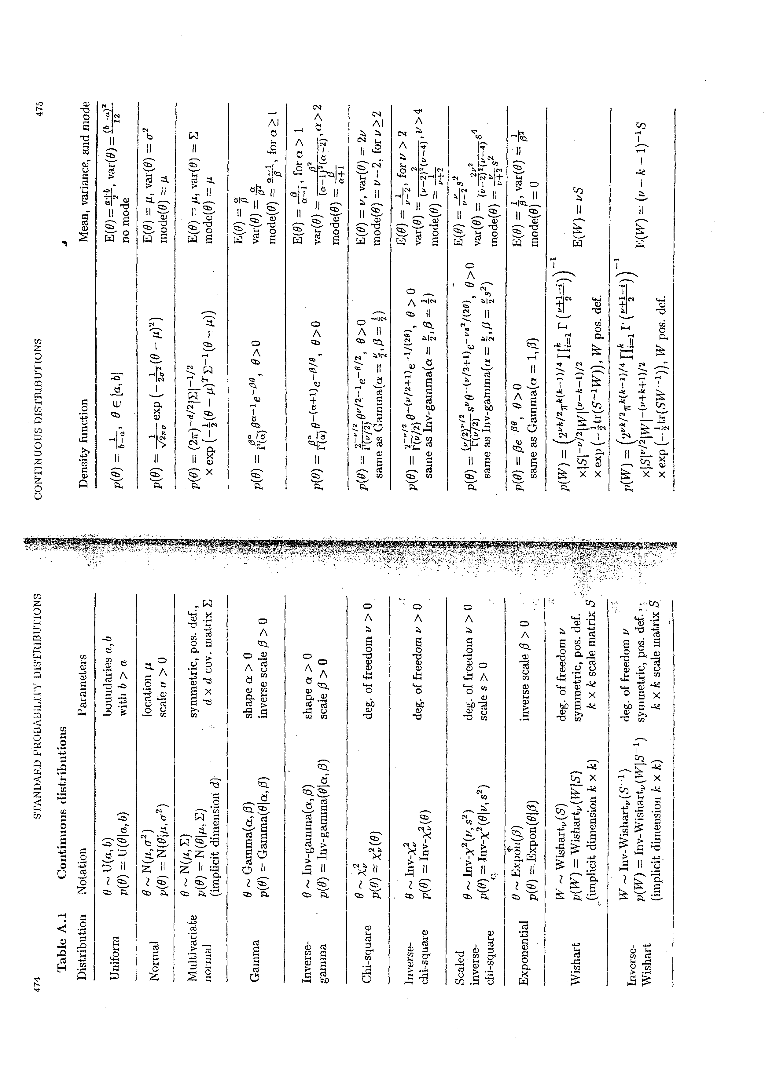
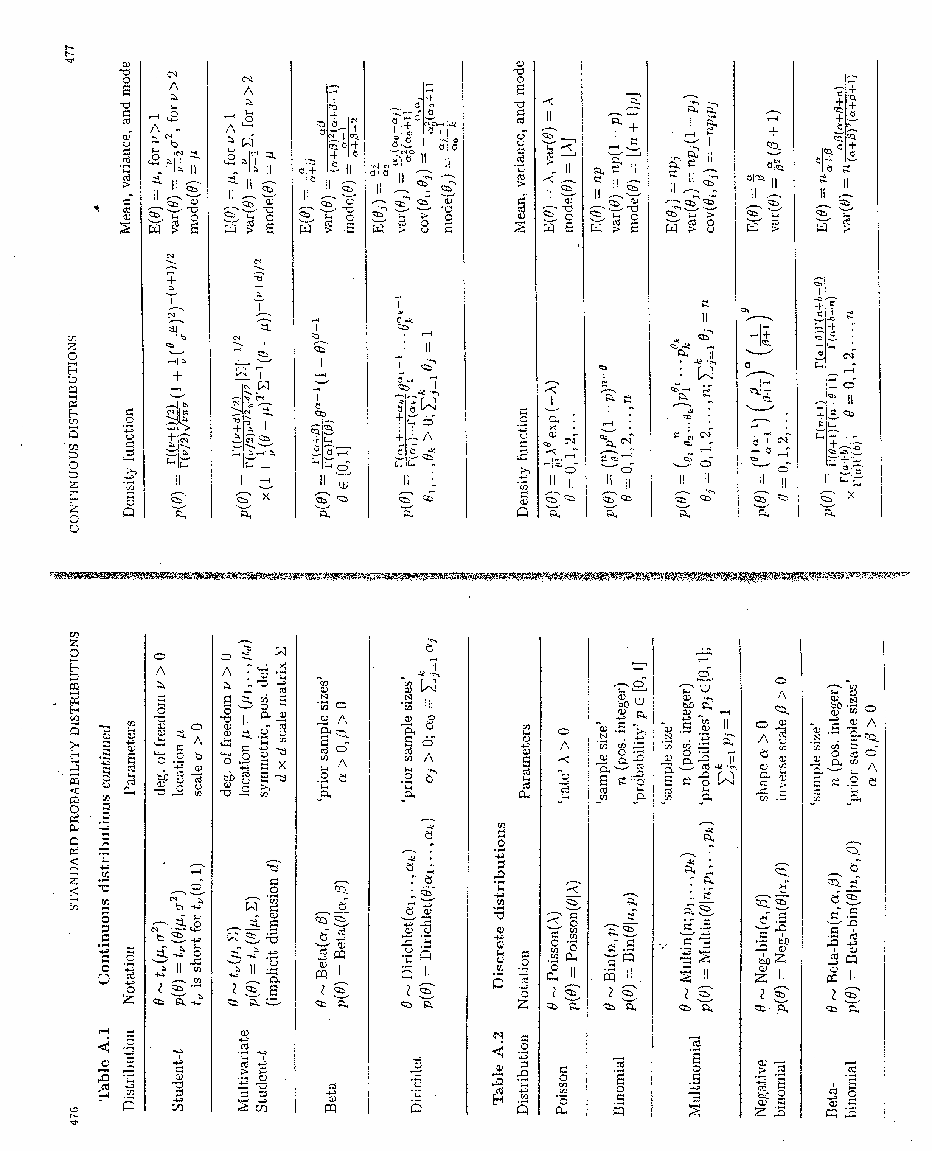
ATTACHMENT
_________________

